REQUEST FOR PROPOSALS FOR

CONCRETE CONSTRUCTION SERVICES

RFP 2023-09A

INSTRUCTIONS/TERMS OF CONTRACT

The City of Crockett will be accepting sealed bids for Concrete Construction Projects, including, but not limited to:
- Curbing and Gutters
- Low Water Crossings
- Sidewalks and Non-Load Bearing Slabs

IT IS UNDERSTOOD that the City of Crockett, Texas, reserves the right to reject in whole or in part, any or all, bids for products and/or services covered in this bid request and to waive informalities or defects in bids or to accept such bids as it shall deem to be in the best interests of the City of Crockett.

BIDS MUST BE placed in an envelope, with each page manually signed, where requested or required, by a person having the authority to bind the firm in a contract and marked clearly on the outside as shown below.

Facsimile or electronic transmittals shall not be accepted.

SUBMISSION OF BIDS:

Sealed bids shall be submitted to:

CITY OF CROCKETT
ATTN: BUTCH CALVERT
200 N. FIFTH STREET
CROCKETT, TX 75835

Front of envelope musts be marked: "SEALED BID: Concrete Projects"

All bids must be received by no later than 5:00 PM, on Monday, September 18, 2023.

The City of Crockett reserves the right to reject any or all bids.

CONTRACT: This contract may be awarded to either the lowest responsible bidder or to the bidder who provides goods or services at the best value for the City, TEX. LOC. GOV. CODE ANN. Sec. 252.043 (2021). This bid may be accepted in whole or in part. When properly accepted by City of Crockett, this bid shall constitute a contract equally binding between the successful bidder and the City of Crockett for a period of one year from the date of acceptance. No different or additional terms will become a part of this contract with the exception of Change Orders.

CHANGE ORDERS: No oral statement of any person shall modify or otherwise change, or affect the terms, conditions, or specifications stated in the resulting contract. All change orders to the contract will be made in writing by the City Administrator.

FUNDING: Funds for payment have been provided through the City of Crockett budget approved by the City Council for this fiscal year only. State of Texas statutes prohibit the obligation and expenditure of public funds beyond the fiscal year for which a budget has been approved. Therefore, anticipated orders or other obligations that may arise past the end of the current City of Crockett fiscal year shall be subject to budget approval.

LATE BIDS: Bids received after the submission deadline will be void and unacceptable. The City of Crockett is not responsible for lateness or non-delivery of mail, carrier, etc., and the date/time stamp by the City Secretary shall be the official time of receipt. Bids received after expressed date and time will be returned unopened to the bidder.

ALTERING BIDS: Bids cannot be altered or amended after the submission deadline. Any interlineation, alteration, or erasure made before opening time must be initialed by the signer of the bid, guaranteeing authenticity.

WITHDRAWAL OF BID: A bid may not be withdrawn or canceled by the bidder without the permission of the City for a period of ninety (90) days following the date designated for the receipt of bids, and bidder so agrees upon submittal of their bid.

CONFLICT OF INTEREST: No public official shall have interest in this contract, in accordance with Vernon’s Texas Codes Annotated, Local Government Code Title 5. Subtitle C, Chapter 171.

ETHICS: The bidder shall not offer, accept gifts or anything of value, nor enter into any business arrangement with any employee, official, or agent of the City of Crockett.

EXCEPTIONS/SUBSTITUTIONS: All bids meeting the intent of this ITB will be considered for award. Bidders taking exception to the specifications, or offering substitutions, shall state these exceptions in the section provided or by attachment as part of the bid. The absence of such a list shall indicate that the bidder has not taken exceptions and shall be responsible to perform in strict accordance with the specifications of the invitation. The City of Crockett reserves the right to accept any and all, or none of the exception(s)/substitution(s) deemed to be in the best interest of the City.

Bids must be submitted using the quantities and units of measure specified by the bid documents. Extension errors in stated prices will be disregarded, and during evaluation the individual unit cost will predominate. Bidders are welcome to suggest changes in quantity, provided better prices or delivery conditions are secured by the City. Suggestions will be considered a valid part of the bid, provided the bidder has also supplied a quotation in the designated quantities and units.

DESCRIPTIONS: Any reference to model and/or make/manufacturer used in bid specifications is descriptive, not restrictive. It is used to indicate the type and quality desires. Bids on items of like quality may be considered.

ADDENDA: Any interpretations, corrections or changes to this ITB and Specifications will be made by addenda. Sole issuing authority of addenda shall be vested in the City Administrator. Addenda will be mailed or emailed to all who are known to have received a copy of this ITB. Bidders shall acknowledge receipt of all addenda.

BID MUST COMPLY: With all federal, state, county and local laws concerning these types of service.

MINIMUM STANDARDS FOR RESPONSIBLE PROSPECTIVE BIDDERS: A prospective bidder must affirmatively demonstrate bidder’s responsibility. A prospective bidder must meet the following requirements:
- Have adequate financial resources, or the ability to obtain such resources as required;
- Be able to comply with the required or proposed delivery or completion schedule;
- Have a satisfactory record of performance;
- Have a satisfactory record of integrity and ethics;
- Be otherwise qualified and eligible to receive an award.

The City of Crockett may request representation and other information sufficient to determine bidder’s ability to meet these minimum standards listed above.

REFERENCES: The City of Crockett requests bidder to supply, with this ITB, a list of at least three (3) references where like services have been supplied by their firm. Include the name of the firm, address, telephone number and name of a representative.

BIDDER SHALL PROVIDE: With the bid response, bidder shall provide any and all documentation required by this ITB. Failure to provide this information may result in rejection of bid.

SUCCESSFUL BIDDER SHALL: Defend, indemnify and save harmless the City of Crockett and all its officers, agents and employees from all suits, actions, or other claims of any character, name and description brought for or on account of any injuries or damages received or sustained by any person, persons, or property on account of any negligent act or fault of the successful bidder, or of any agent, employee, subcontractor or supplier in the execution of, or performance under, any contract which may result from bid award.

Successful bidder indemnities and will indemnify and save harmless the City of Crockett from liability, claim or demand on their part, agents, servants, customers, and/or employees whether such liability, claim or demand arise from event or casualty happening or within the occupied premises themselves or happening upon or in any of the halls, entrances, stairways or approaches of or to the facilities within which the occupied premises are located. Successful bidder shall pay any judgment with costs which may be obtained against the City of Crockett growing out of such injury or damages.

Successful bidder will provide a performance or payment bond in compliance with TEX. LOC. GOV. CODE ANN. Sec. 252.044 (2021), provide commercial general liability insurance of at least $1,000,000 per instance/$2,000,000 aggregate and worker's compensation insurance.

TERMINATION OF CONTRACT: This contract shall remain in effect until contract expires, delivery and acceptance of products and/or performance of services ordered, or until terminated by either party with a thirty (30) day written notice prior to any cancellation. The successful bidder must state therein the reasons for such cancellation. The City of Crockett reserves the right to award canceled contract to next best bidder as it deems to be in the best interest of the City.

TERMINATION OR DEFAULT: The City of Crockett reserves the right to enforce the performance of this contract in any manner prescribed by law or deemed to be in the best interest of the City in the event of breach or default of this contract. The City of Crockett reserves the right to terminate the contract immediately in the event the successful bidder(s) fails to:
- Meet delivery or completion schedules:
- Defaults in the payment of any fees; or
- Fails to perform in accordance with the specifications included in this contract.

Breach of contract or default authorizes the City of Crockett to exercise any or all of the following rights:
- The City of Crockett may take possession of the assigned premises and any fees accrued or becoming due to date;
- The City of Crockett may take possession of all goods, fixtures and materials of successful bidder therein and may foreclose its lien against such personal property, applying the proceeds toward fees due or thereinafter becoming due;
In the event the successful bidder shall fail to perform, keep, or observe any of the terms and conditions to be performed, kept or observed, the City of Crockett shall give the successful bidder written notice of such default; and in the event said default is not remedied to the satisfaction and approval of the county within two (2) working days of receipt of such notice by the successful bidder, default will be declared and all the successful bidder’s rights shall terminate.

The Bidder, in submitting this bid, agrees that the City of Crockett shall not be liable to prosecution for damages in the event that the City declares the bidder in default.

NOTICE: Any notice provided by this bid (or required by Law) to be given to the successful bidder by the City of Crockett shall be conclusively deemed to have been given and received on the next day after such written notice has been deposited in the mail in the City of Crockett, Texas, by Registered or Certified Mail with sufficient postage affixed thereto, addressed to the successful bidder at the address so provided; provided this shall not prevent the giving of actual notice in any other manner.

PAYMENT: Will be made upon receipt and acceptance by the City of Crockett for item(s) ordered and receipt of a valid invoice, in accordance with Chapter 28, Title 4 of the Texas Property Code. Successful bidder(s) is required to pay subcontractors within ten (10) days.

SALES TAX: The City of Crockett is exempt by law from payment of Texas Sales Tax and Federal Excise Tax. Bidder shall include any sales taxes from concession sales of taxable items on county property in the total price of the sale, and shall be responsible to report and pay such taxes in a timely manner.

WARRANTY: Successful bidder shall warrant that all items/services shall conform to the proposed specifications and/or warranties as stated in the Uniform Commercial Code and be free from all defects in material, workmanship and title.

REMEDIES: The successful bidder and the City of Crockett agree that both parties have all rights, duties, and remedies available as stated in the Uniform Commercial Code, Texas Property Code and the Texas Local Government Code.

VENUE: This agreement will be governed and construed according to the laws of the State of Texas. This agreement is performable in the City of Crockett, Texas. Jurisdiction and venue of any action relating to this agreement and any related agreements is exclusively in the State District Courts of Houston County, Texas.

ASSIGNMENT: The successful bidder shall not sell, assign, transfer or convey this contract, in whole or in part, without the prior written consent of the City of Crockett.

DESIGN, STRENGTH, QUALITY: Materials must conform to the highest standards of manufacturing practice. Products to be supplied under this purchase order shall be free from contamination. Should products be contaminated, or found to fall below standards, the City reserves the right to reject the materials, at no cost to the City.

ITEMS: Supplies under this contract shall be subject to the City’s approval. Items found defective or not meeting specifications shall be picked up and replaced by the successful bidder at the next service date at no expense to the City. If item is not picked up within one (1) week after notification, the item will become a donation to the City for disposition.

SILENCE OF SPECIFICATION: The apparent silence of these specifications as to any detail or to the apparent omission of a detailed description concerning any point, shall be regarded as meaning that only the best commercial practices are to prevail. All interpretations of these specifications shall be made on the basis of this statement.

Each insurance policy to be furnished by successful bidder shall include, by endorsement to the policy, a statement that a notice shall be given to the City of Crockett by certified mail thirty (30) days prior to cancellation or upon any material change in coverage.

ORDERING: Bidder shall indicate, on the bid invitation, the contact information to place orders; this includes the contact’s name and phone number.

DELIVERY: All deliveries, or services, are to be scheduled by authorized City of Crockett personnel at the time the order for the product is placed.

Delivery shall be made from vehicles equipped with State regulated and approved devices. Delivery reports shall be furnished in duplicate with one copy left at each delivery location and one copy attached to an itemized statement.

Title and Risk of Loss of the goods shall not pass to the City of Crockett until the City actually accepts and takes possession of the goods at the point or points of delivery.

DELIVERY LOCATIONS: Delivery locations and delivery quantities will vary throughout the City of Crockett, depending on the location of the job site.

FAILURE TO DELIVER: In the event the Supplier is unable to furnish any item within a reasonable time after order is placed due to strikes, war, or any reason beyond the Supplier’s control, the City reserves the right to purchase these items from the source of its choice without causing the cancellation of this contract.

Supplier will be required to notify the City Official placing an order in the event of unforeseen delays in the delivery of specified shipments. If the Supplier fails to deliver by the specified delivery date or is unable to give acceptable reasons for the delay, the City of Crockett reserves the right to cancel the portion of the order(s) that the Supplier has failed to deliver and purchase it elsewhere, charging the difference in price to the Supplier awarded the contract. The City of Crockett also reserves the right the cancel the contract for failure to perform to the specifications of the contract.

SPILLAGE AND CLEANUP: The vendor shall be held responsible for all spillage which may occur during transit, construction, and loading or unloading operations. The vendor shall immediately report any spillage to the office that ordered the clean up the spillage. Failure to do so shall initiate corrective action and back charge to the vendor of any incurred costs.

SCOPE: The term of this contract is twelve (12) months; failure to bid a twelve (12) month contract may result in disqualification of the bid. The City reserves the option to extend this contract for up to four (4) additional twelve (12) month terms upon agreement with the vendor, based upon the same terms, conditions and pricing as the original year. Renewal is subject to approval by the City Council of Crockett. Once renewal options are exhausted, the contract must be rebid. The City of Crockett reserves the right to rebid at any time as is in its best interest and is not automatically bound to renew.

PRICING: The escalation of cost shall be limited to a maximum of 5%, per year, over the term of the contract. De-escalation shall have no limit. In the event of an increase or decrease, no written notice shall be required unless the increase exceeds the 5%, per year, maximum escalation in which case product shall be delivered under this contract until the notification by the vendor is received and accepted by the City of Crockett.

CONSTANT PRICE: Included in the constant figure is all the bidder’s overhead costs including delivery of products and services provided to the City of Crockett, any applicable taxes, and the profit the bidder adds. This Constant remains the same throughout the contract period.

COST – CURB AND GUTTER: The cost per linear foot is the actual cost to the City of Crockett for completed construction, per linear foot of curb and gutter.
*Details and specifications listed on Exhibit A.

COST - LOW WATER CROSSING: The cost per square foot is the actual cost to the City of Crockett for completed construction, per square foot.
*Details and specifications listed on Exhibit B.

COST – SIDEWALKS AND NON-LOAD BEARING SLABS: The cost per square foot is the actual cost to the City of Crockett for completed construction, per square foot.
*Details and specifications listed on Exhibit C.

REMARKS:

ORDERING / CONTACT INFORMATION:

NAME: PHONE #:

BID / ITB PACKET SUBMITTED BY:
(Must completed & Signed by Authorized Agent and is for submission only)

COMPANY NAME:
ADDRESS:
TELEPHONE #: FAX #:
EMAIL:
NAME: TITLE:
SIGNATURE: DATE:

ANY QUESTIONS concerning this invitation to bid and specifications should be directed to the City Administrator or City Secretary at (936) 544-5156, Ext. 203.

EXHIBIT A: BID SHEET

I hereby offer for sale, to the City of Crockett, products which meet or exceed your specifications: Prices effective time period listed in the contract.

Curb and Gutter Specifications:
- 12” gutter width
- 6” curb width
- 6” curb height
- 6” thick base
- 12” total height
- 18” total base width
- #4 Rebar, 4 strands (entire length of curbing)
- Saw cut every five (5) feet
- Expansion Joint every twenty (20) feet
- 4,000 P.S.I. concrete
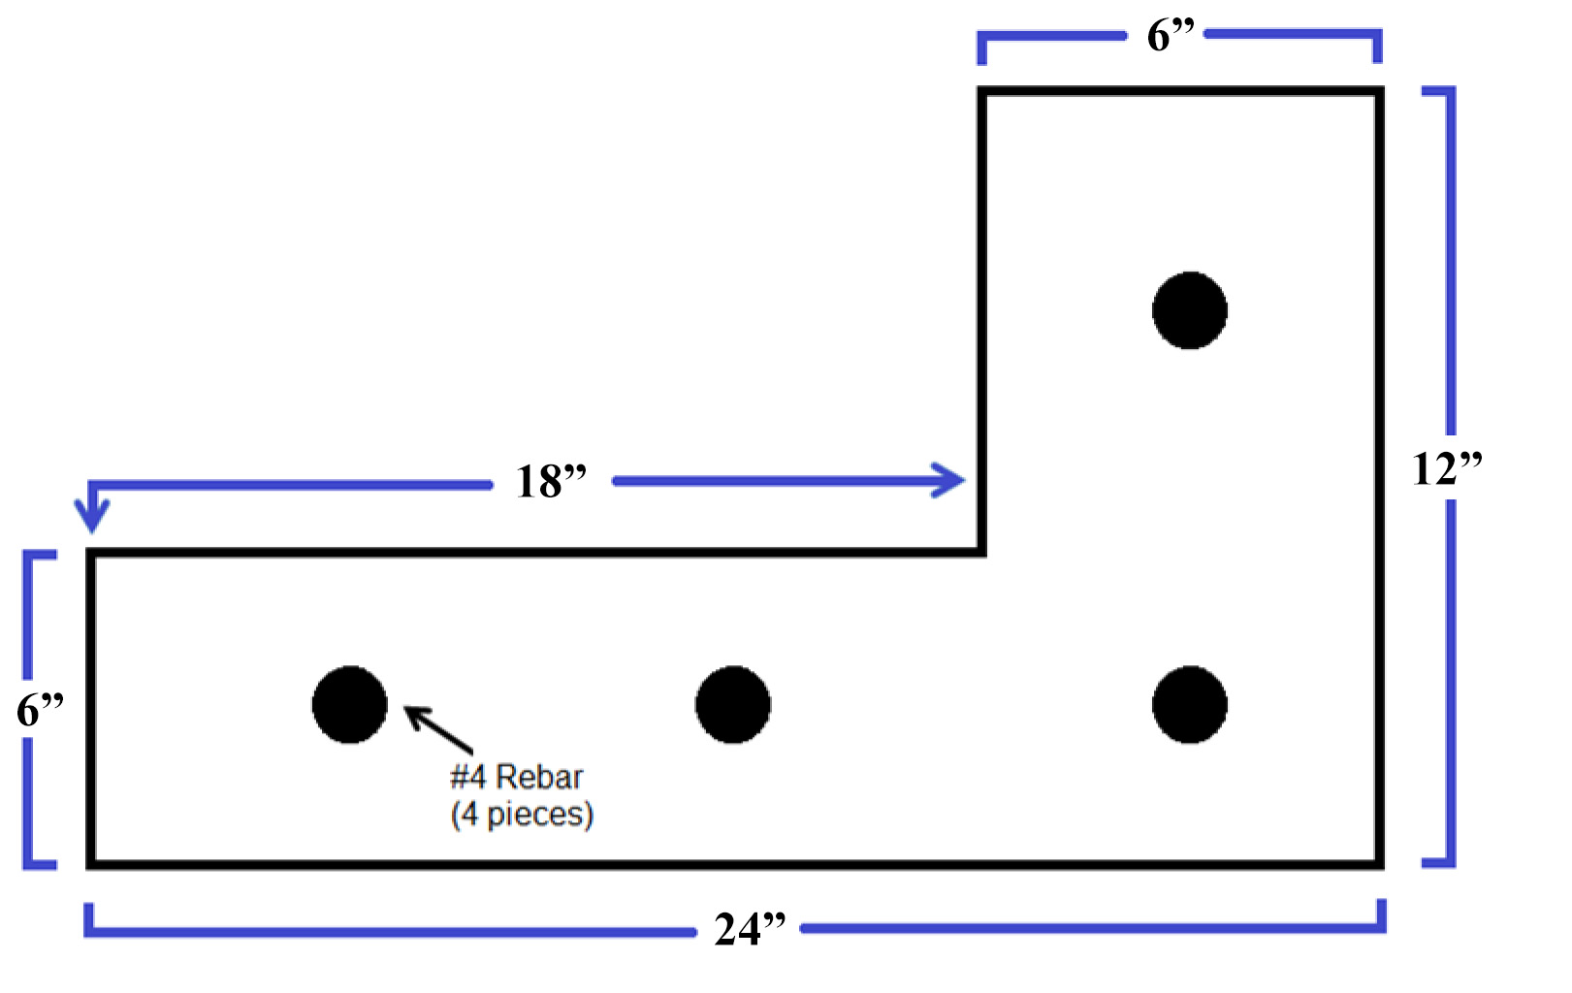
Total Price: $_________________ per linear foot

Company Name:
Representative: Title:
Signature: Date:
The above price is good for _________ days.

EXHIBIT B: BID SHEET

I hereby offer for sale, to the City of Crockett, products which meet or exceed your specifications: Prices effective time period listed in the contract.

Low Water Crossing Specifications:
- 8 feet wide (Approximate & may vary)
- 35 feet long (Approximate & may vary)
- 5 inch thick slab
- Trough Depth will vary, depending on grade
- Reinforced with #4 rebar, 16 inch on center
- 12 inch X 12 inch Perimeter Footing
- 4,000 P.S.I. Concrete

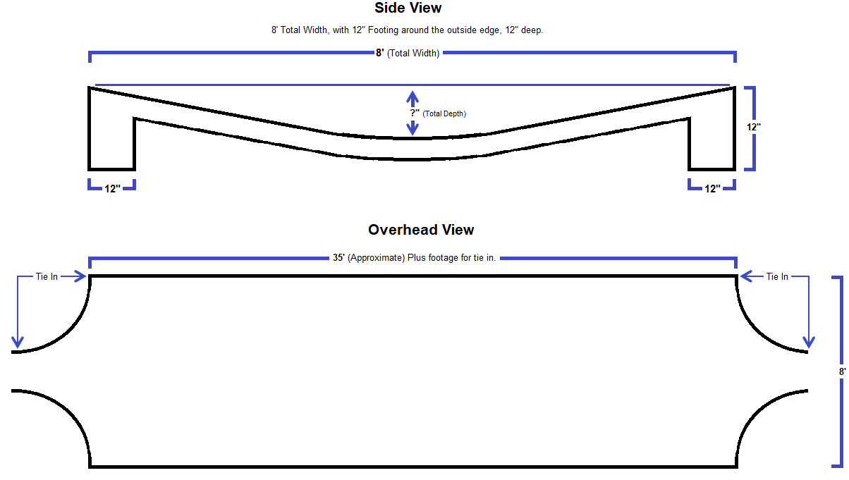

Total Price: $ per square foot.

Company Name:
Representative: Title:
Signature: Date:
The above price is good for _________ days.

EXHIBIT C: BID SHEET

I hereby offer for sale, to the City of Crockett, products which meet or exceed your specifications: Prices effective time period listed in the contract.

Sidewalks and Non-Load Bearing Slabs Specifications:
- #3 Rebar on 16 inch centers
- 3,500 P.S.I concrete
- 4 inch thick concrete, if different, cost will be negotiated at time of project
- Perimeter Footing, if required, cost will be negotiated at time of project

Total Price: of $ per square foot.

Company Name:
Representative: Title:
Signature: Date:
The above price is good for _________ days.

